Rural Living Canada

In the Field: Cohn Farms Expands Processing Capabilities
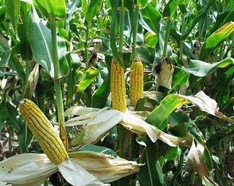
- Greenbelt Fund Announces First Round of Grants -
BRADFORD, Ontario, February 17, 2011 /Canada NewsWire/ - Local food producer Cohn Farms is working hard to get more of the great things that grow in Ontario from the field to the kitchens of public institutions. Now, with funding from the Ontario government, Cohn Farms will be able to expand their offerings to provide more Ontario food to daycares, schools, universities and colleges, hospitals and long-term care facilities. Growing the amount of Ontario food in our public institutions will also benefit farmers, the economy and our environment.
"Farmers are at the heart of our agricultural community. Through these grants the McGuinty government is investing in a strong future for our farmers and for agriculture. I want to congratulate Cohn Farms on their work to serve the good things that grow in Ontario."
- Carol Mitchell, Minister of Agriculture, Food and Rural Affairs
The funding for Cohn Farms and other grantees is being administered by the new Greenbelt Fund via its program, the Broader Public Sector Investment Fund: Promoting Ontario Food.
"Cohn Farms has identified a collaborative solution to help Greenbelt farmers meet the unique needs of public institutions. From large and small farm operations to distributors, the Greenbelt Fund is supporting all levels of the food value chain to create a ripple effect of change throughout the food system."
- Burkhard Mausberg, President, Greenbelt Fund
Cohn Farms is taking a unique and collaborative approach to supplying the broader public sector with fresh Ontario produce. By building a large co-packing facility, Cohn Farms will provide an opportunity for up to 30 farmers to gain instant access to processing equipment. Cohn Farms is taking a step to create a cluster of farmers that supply fresh produce and meet the preparation and processing needs of broader public sector institutions.
"Our co-packing facility will allow us to provide a more diverse supply of produce to Ontario's public institutions. We are excited for the opportunity this grant is providing us and the farmers in the Greenbelt."
- Keith Cohn, Cohn Farms
About the Greenbelt Fund:
The Greenbelt Fund is helping to increase the amount of Ontario food served in daycares, schools, universities and colleges, hospitals and long-term care facilities through its program, the Broader Public Sector Investment Fund: Promoting Ontario Food.
With funding from the Ontario government, this program provides grants to local food industry leaders, producers, distributors, food service providers and public institutions working to serve more Ontario food. Helping to overcome challenges, support economic growth and the sustainability of agriculture in Ontario, the Fund will aim to create systemic change to permanently increase the amount of local food in the province's public institutions. For more information about the program and grants, please visit www.ontariofresh.ca.

